Pentagonal Prism
# Source: AI Source: Provided by: [Data Path: Persons Table -> ID Column: 1, Name_En Column: Motasem Essam] -> From: [ChatGPT] on [7/25/2026]
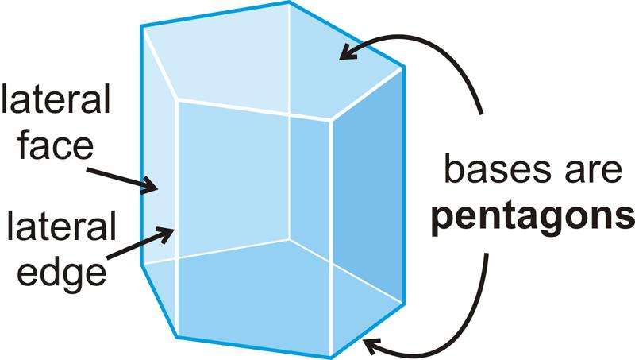
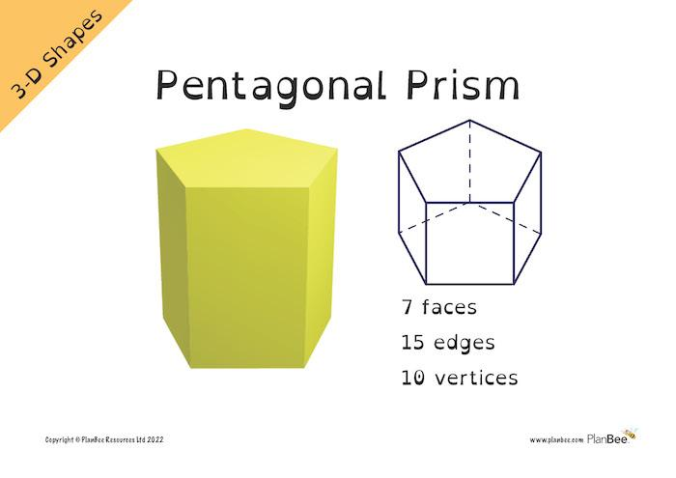
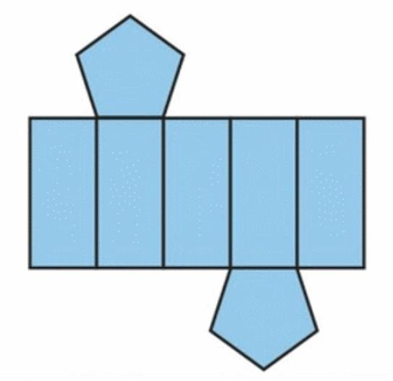

Definition
# Source: AI Source: Provided by: [Data Path: Persons Table -> ID Column: 1, Name_En Column: Motasem Essam] -> From: [ChatGPT] on [7/25/2026]
A pentagonal prism is a three-dimensional polyhedron with two congruent, parallel pentagonal bases connected by five lateral faces.
Each pentagonal base has five sides and five vertices. The lateral faces connect corresponding edges of the two bases, forming a closed solid.
In a right pentagonal prism, the lateral edges are perpendicular to the bases, and the lateral faces are rectangles. In an oblique pentagonal prism, the lateral edges are inclined to the bases, and the lateral faces are parallelograms.

Simple Definition
# Source: AI Source: Provided by: [Data Path: Persons Table -> ID Column: 1, Name_En Column: Motasem Essam] -> From: [ChatGPT] on [7/25/2026]
A pentagonal prism is a solid shape with two identical pentagons at opposite ends and five side faces.

Classification Tree
# Source: AI Source: Provided by: [Data Path: Persons Table -> ID Column: 1, Name_En Column: Motasem Essam] -> From: [ChatGPT] on [7/25/2026]
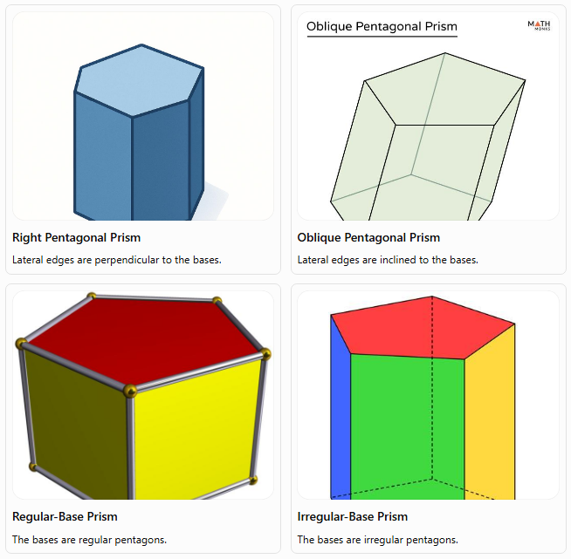
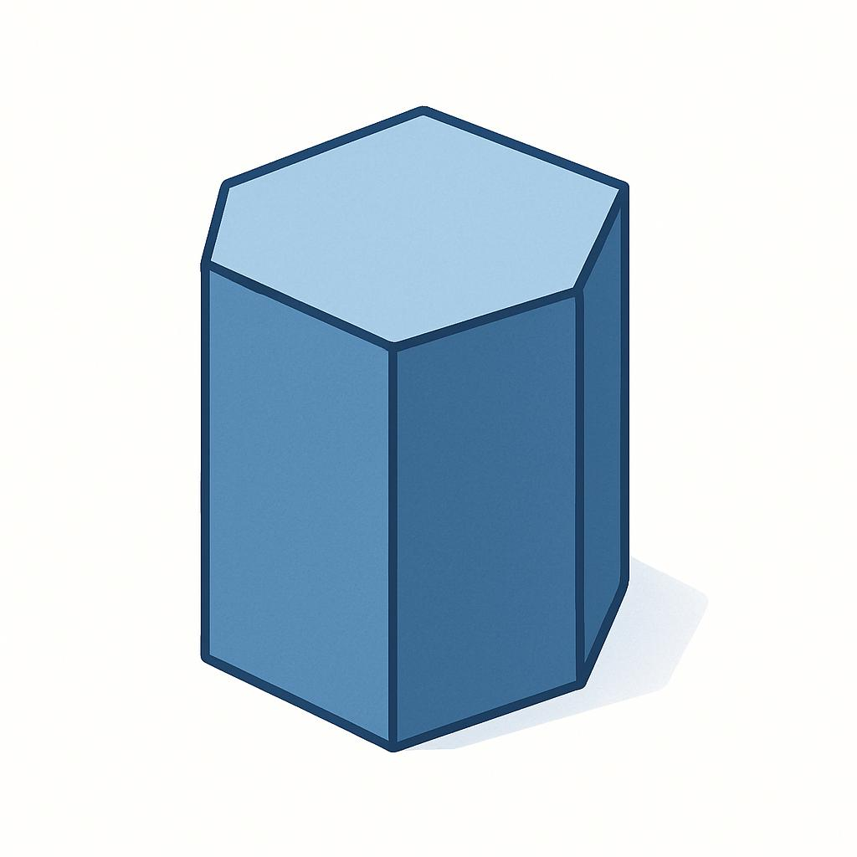
Right Pentagonal Prism
Lateral edges are perpendicular to the bases.
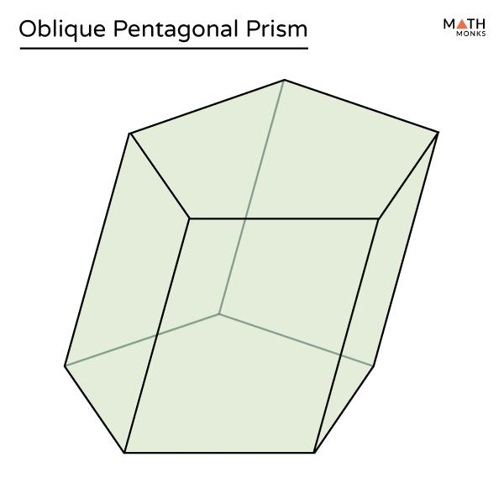
Oblique Pentagonal Prism
Lateral edges are inclined to the bases.
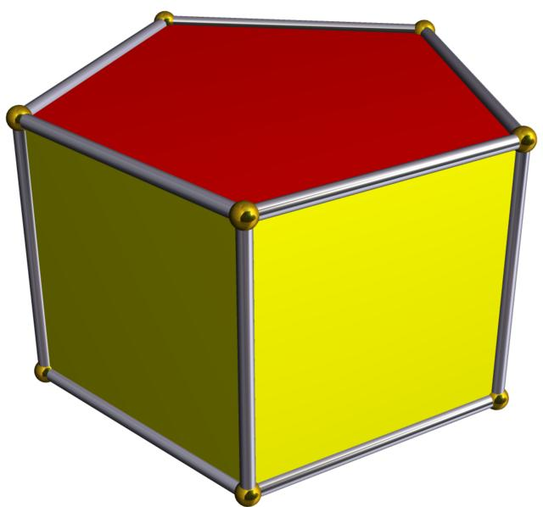
Regular-Base Prism
The bases are regular pentagons.
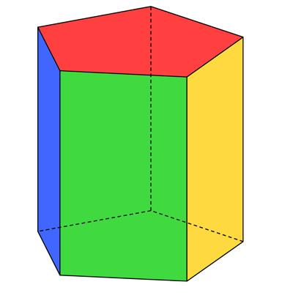
Irregular-Base Prism
The bases are irregular pentagons.
These classifications describe different properties. For example, a prism can be both right and regular-base.

Key Characteristics
# Source: AI Source: Provided by: [Data Path: Persons Table -> ID Column: 1, Name_En Column: Motasem Essam] -> From: [ChatGPT] on [7/25/2026]
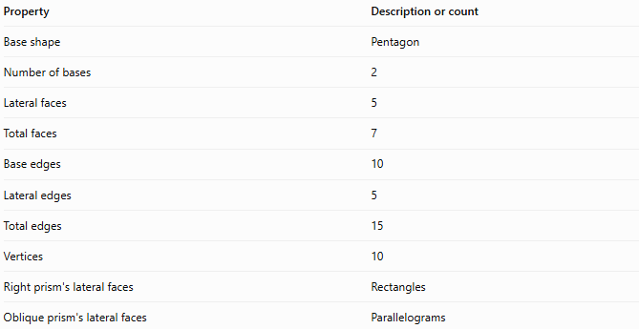
Property | Description or count
Base shape | Pentagon
Number of bases | 2
Lateral faces | 5
Total faces | 7
Base edges | 10
Lateral edges | 5
Total edges | 15
Vertices | 10
Right prism's lateral faces | Rectangles
Oblique prism's lateral faces | Parallelograms

Geometric Representation
# Source: AI Source: Provided by: [Data Path: Persons Table -> ID Column: 1, Name_En Column: Motasem Essam] -> From: [ChatGPT] on [7/25/2026]
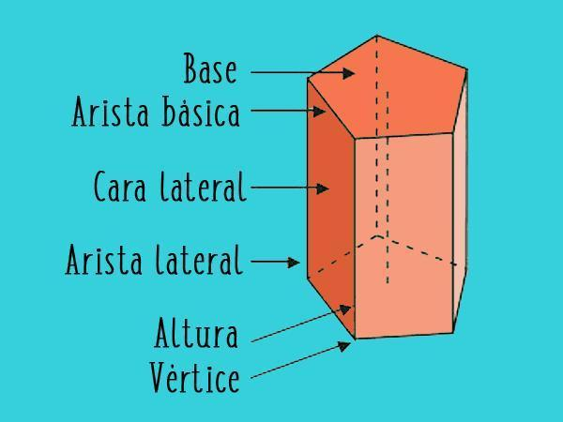
The main components of a pentagonal prism are:
- Pentagonal bases: The two congruent, parallel pentagons.
- Lateral faces: The five faces connecting the bases.
- Base edges: The ten edges forming the boundaries of the two pentagonal bases.
- Lateral edges: The five edges joining corresponding vertices of the bases.
- Vertices: The ten corner points of the solid.
- Height: The perpendicular distance between the two base planes.

Mathematical Representations and Formulas
# Source: AI Source: Provided by: [Data Path: Persons Table -> ID Column: 1, Name_En Column: Motasem Essam] -> From: [ChatGPT] on [7/25/2026]
Let:
- $B$ = area of one pentagonal base
- $p$ = perimeter of one base
- $h$ = perpendicular height of the prism
- $a$ = side length of a regular pentagonal base
- $r$ = apothem of a regular pentagonal base

A. Number of faces, edges, and vertices
# Source: AI Source: Provided by: [Data Path: Persons Table -> ID Column: 1, Name_En Column: Motasem Essam] -> From: [ChatGPT] on [7/25/2026]
For a prism with an $n$-sided polygon as its base:
$$F=n+2, E=3n, V=2n$$
For a pentagonal prism, $n=5$:
$$F=5+2=\boxed{7}$$
$$E=3\left(5\right)=\boxed{15}$$
$$V=2\left(5\right)=\boxed{10}$$

B. Area of a regular pentagonal base
# Source: AI Source: Provided by: [Data Path: Persons Table -> ID Column: 1, Name_En Column: Motasem Essam] -> From: [ChatGPT] on [7/25/2026]
For a regular pentagon with side length $a$:
$$B=\frac{14}{\sqrt{5\left(5+2\sqrt{5}\right)}} a^{2}$$
Its perimeter is:
$$p=5a$$
Alternatively, using the apothem:
$$B=\frac{12}{p}r$$

C. Volume
# Source: AI Source: Provided by: [Data Path: Persons Table -> ID Column: 1, Name_En Column: Motasem Essam] -> From: [ChatGPT] on [7/25/2026]
The volume of any prism is the area of its base multiplied by its perpendicular height:
$$\boxed{V=Bh}$$
For a regular pentagonal prism:
$$V=\frac{14}{\sqrt{5\left(5+2\sqrt{5}\right)}} a^{2}h$$

D. Lateral surface area
# Source: AI Source: Provided by: [Data Path: Persons Table -> ID Column: 1, Name_En Column: Motasem Essam] -> From: [ChatGPT] on [7/25/2026]
For a right pentagonal prism:
$$\boxed{A_{L}=ph}$$
For a regular pentagonal prism:
$$\boxed{A_{L}=5ah}$$
For an oblique prism, calculate the actual areas of its five lateral parallelograms and add them together.

E. Total surface area
# Source: AI Source: Provided by: [Data Path: Persons Table -> ID Column: 1, Name_En Column: Motasem Essam] -> From: [ChatGPT] on [7/25/2026]
The total surface area includes both bases and all lateral faces:
$$\boxed{A_{T}=A_{L}+2B}$$
For a regular right pentagonal prism:
$$\boxed{A_{T}=5ah+2B}$$

Worked Examples
# Source: AI Source: Provided by: [Data Path: Persons Table -> ID Column: 1, Name_En Column: Motasem Essam] -> From: [ChatGPT] on [7/25/2026]
Example 1: Counting faces, edges, and vertices
Problem: Find the number of faces, edges, and vertices of a pentagonal prism.
Solution:
The base is a pentagon, so $n=5$.
$$F=n+2=5+2=\boxed{7}$$
$$E=3n=3\left(5\right)=\boxed{15}$$
$$V=2n=2\left(5\right)=\boxed{10}$$
Answer: The prism has 7 faces, 15 edges, and 10 vertices.
Example 2: Calculating volume
Problem: A pentagonal prism has a base area of $30{\text{ cm}}^{2}$ and a perpendicular height of $12\text{ cm}$. Find its volume.
Solution:
$$V=Bh$$
Substitute the given values:
$$V=30×12$$
$$\boxed{V=360{\text{ cm}}^{3}}$$
Answer: $360{\text{ cm}}^{3}$.
Example 3: Calculating total surface area
Problem: A regular right pentagonal prism has a base side length of $4\text{ cm}$, a base area of approximately $27.53{\text{ cm}}^{2}$, and a height of $10\text{ cm}$. Find its total surface area.
Step 1: Calculate the base perimeter.
$$p=5a=5\left(4\right)=20\text{ cm}$$
Step 2: Calculate the lateral surface area.
$$A_{L}=ph=20\left(10\right)=200{\text{ cm}}^{2}$$
Step 3: Calculate the total surface area.
$$A_{T}=A_{L}+2B$$
$$A_{T}=200+2\left(27.53\right)$$
$$\boxed{A_{T}≈255.06{\text{ cm}}^{2}}$$
Answer: Approximately $255.06{\text{ cm}}^{2}$.
Example 4: Verifying Euler's formula
Euler's formula for a convex polyhedron is:
$$V-E+F=2$$
For a pentagonal prism:
$$10-15+7=2$$
$$\boxed{2=2}$$
Therefore, the pentagonal prism satisfies Euler's formula.

Comparison with Related Prisms
# Source: AI Source: Provided by: [Data Path: Persons Table -> ID Column: 1, Name_En Column: Motasem Essam] -> From: [ChatGPT] on [7/25/2026]
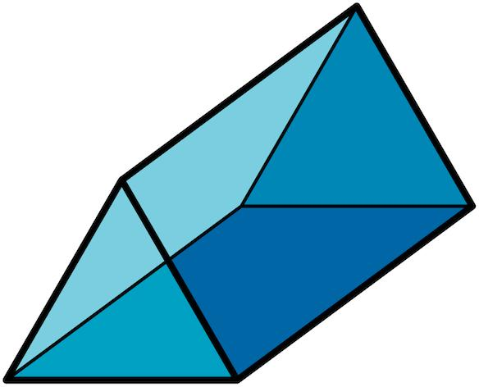
Triangular Prism
Triangular bases; 5 faces, 9 edges, and 6 vertices.
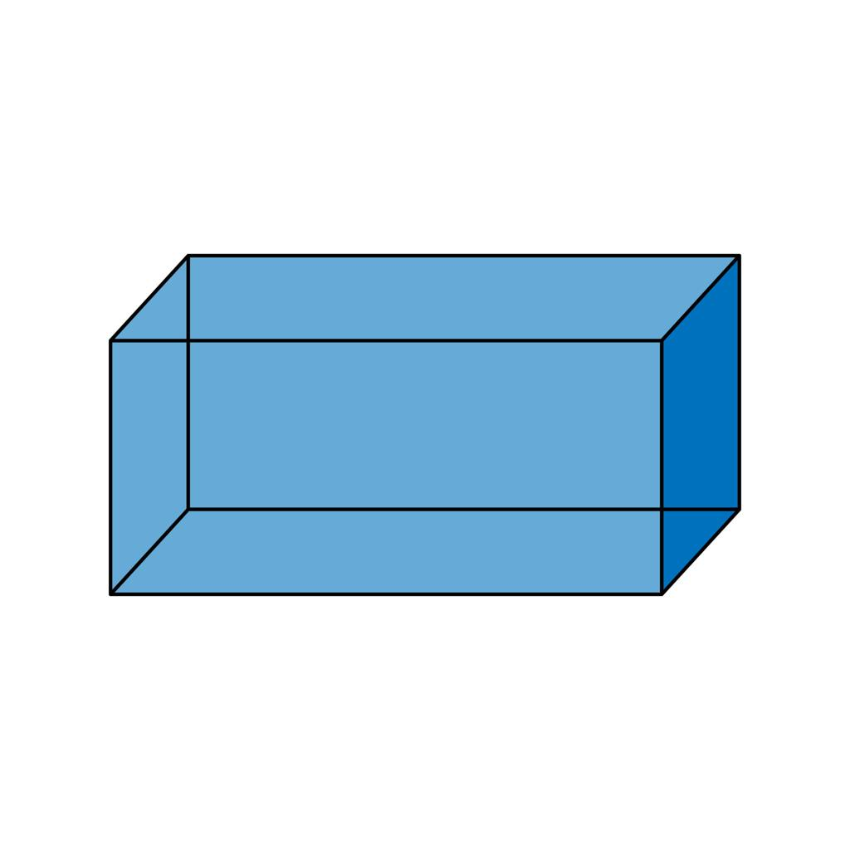
Quadrilateral Prism
Quadrilateral bases; 6 faces, 12 edges, and 8 vertices. A rectangular prism is a common example.
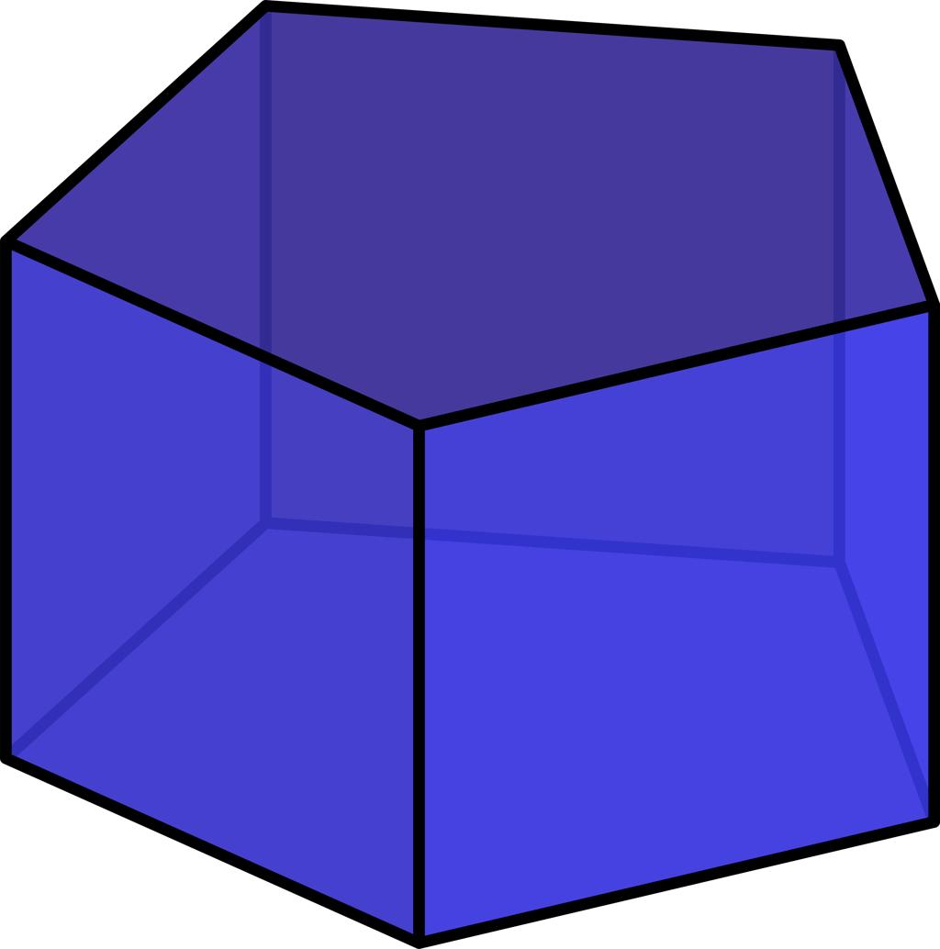
Pentagonal Prism
Pentagonal bases; 7 faces, 15 edges, and 10 vertices.
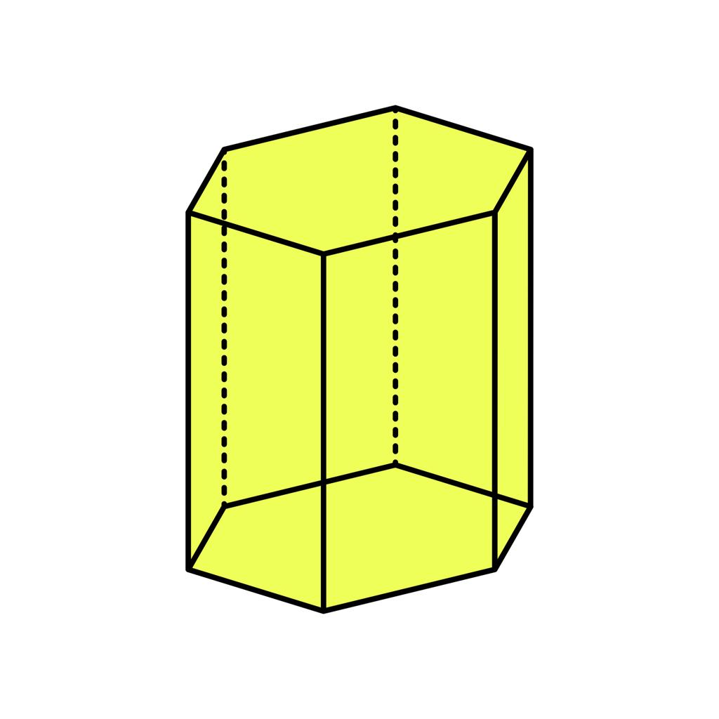
Hexagonal Prism
Hexagonal bases; 8 faces, 18 edges, and 12 vertices.
As the number of sides of the polygonal base increases by one, the prism gains one lateral face, three edges, and two vertices.

Constructing Pentagonal Prism in Solid Geometry

Instruments Used
# Source: AI Source: Provided by: [Data Path: Persons Table -> ID Column: 1, Name_En Column: Motasem Essam] -> From: [ChatGPT] on [7/25/2026]
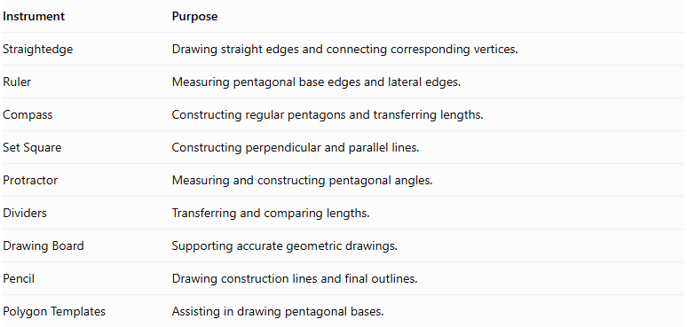
Instrument | Purpose
Straightedge | Drawing straight edges and connecting corresponding vertices.
Ruler | Measuring pentagonal base edges and lateral edges.
Compass | Constructing regular pentagons and transferring lengths.
Set Square | Constructing perpendicular and parallel lines.
Protractor | Measuring and constructing pentagonal angles.
Dividers | Transferring and comparing lengths.
Drawing Board | Supporting accurate geometric drawings.
Pencil | Drawing construction lines and final outlines.
Polygon Templates | Assisting in drawing pentagonal bases.

Construction Procedures

Constructing a Right Pentagonal Prism
# Source: AI Source: Provided by: [Data Path: Persons Table -> ID Column: 1, Name_En Column: Motasem Essam] -> From: [ChatGPT] on [7/25/2026]
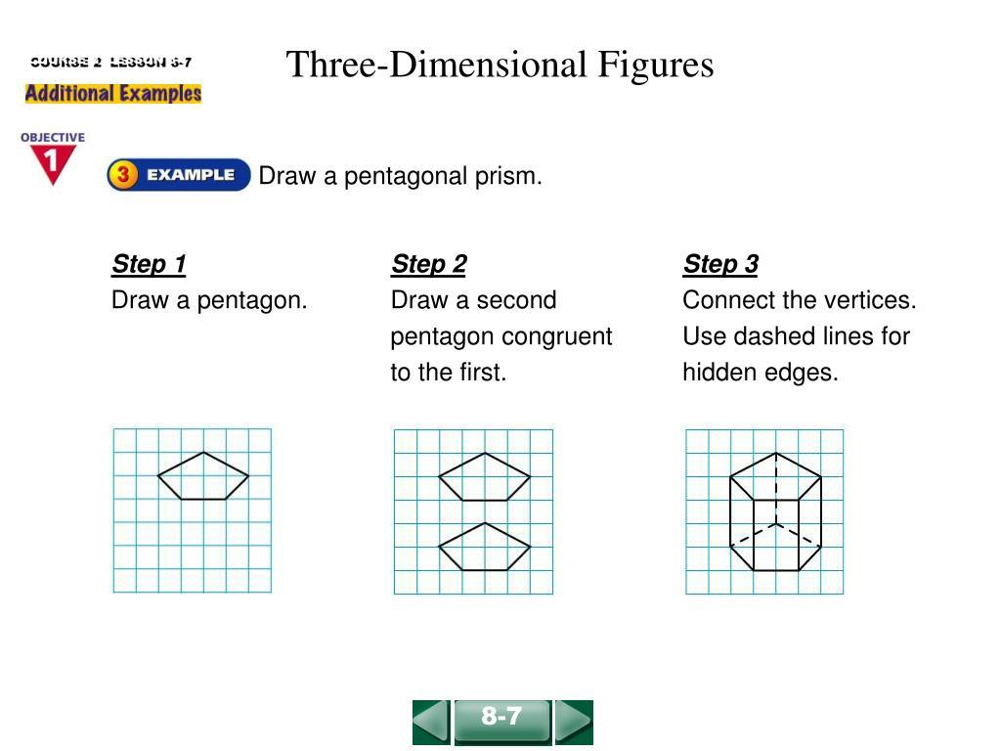
- Construct the first pentagonal base using suitable geometric instruments.
- Determine the required perpendicular height of the prism.
- Construct a second congruent pentagon parallel to the first base.
- Align the corresponding vertices along perpendicular lateral edges.
- Connect the corresponding vertices using straight lines.
- Complete the five rectangular lateral faces.
- Darken the visible edges and represent hidden edges with dashed lines when necessary.

Constructing an Oblique Pentagonal Prism
# Source: AI Source: Provided by: [Data Path: Persons Table -> ID Column: 1, Name_En Column: Motasem Essam] -> From: [ChatGPT] on [7/25/2026]
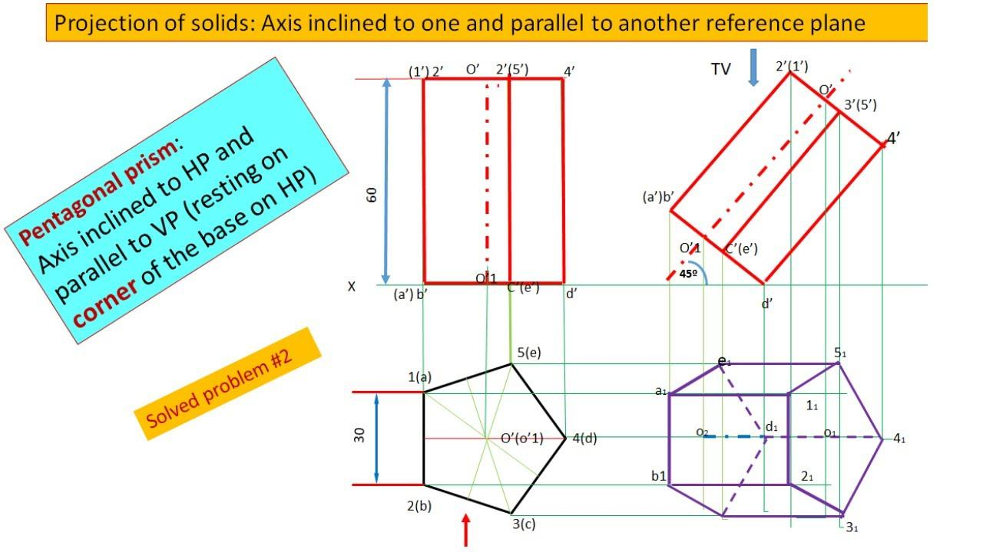
- Construct the first pentagonal base.
- Determine the required lateral-edge direction and length.
- Construct a second congruent pentagon in a parallel plane, displaced in the intended inclined direction.
- Connect corresponding vertices using parallel and equal lateral edges.
- Complete the five lateral parallelogram faces.
- Distinguish visible and hidden edges.

Constructing a Pentagonal Prism from a Net
# Source: AI Source: Provided by: [Data Path: Persons Table -> ID Column: 1, Name_En Column: Motasem Essam] -> From: [ChatGPT] on [7/25/2026]
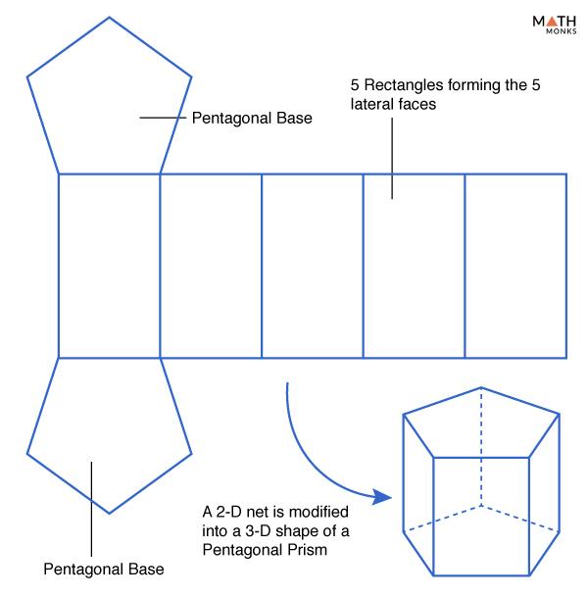
- Draw two congruent pentagonal bases.
- Construct five rectangles or parallelograms, depending on the intended prism.
- Attach each lateral face to its corresponding pentagonal base edge.
- Arrange the faces into a connected net.
- Cut out the net when constructing a physical model.
- Fold along the lateral edges.
- Join the corresponding boundary edges to form the pentagonal prism.

Constructing a Pentagonal Prism by Extrusion
# Source: AI Source: Provided by: [Data Path: Persons Table -> ID Column: 1, Name_En Column: Motasem Essam] -> From: [ChatGPT] on [7/25/2026]
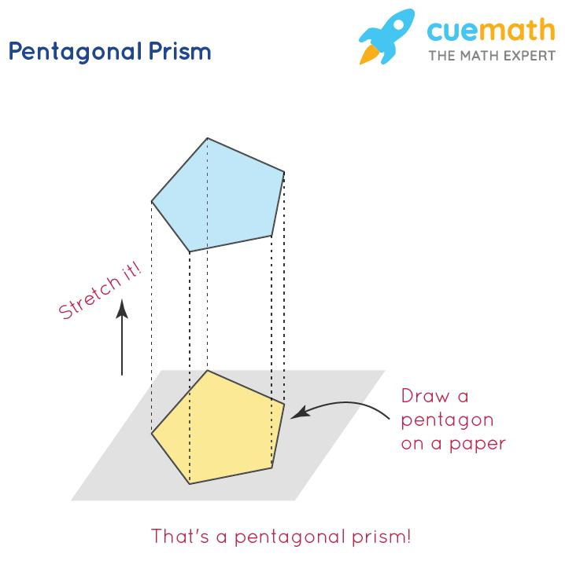
- Construct a pentagonal base.
- Establish the direction of translation.
- Transfer the pentagon along that direction while preserving its shape and dimensions.
- Connect the five corresponding vertices.
- Complete the lateral faces.

Applications of Pentagonal Prisms
# Source: AI Source: Provided by: [Data Path: Persons Table -> ID Column: 1, Name_En Column: Motasem Essam] -> From: [ChatGPT] on [7/25/2026]
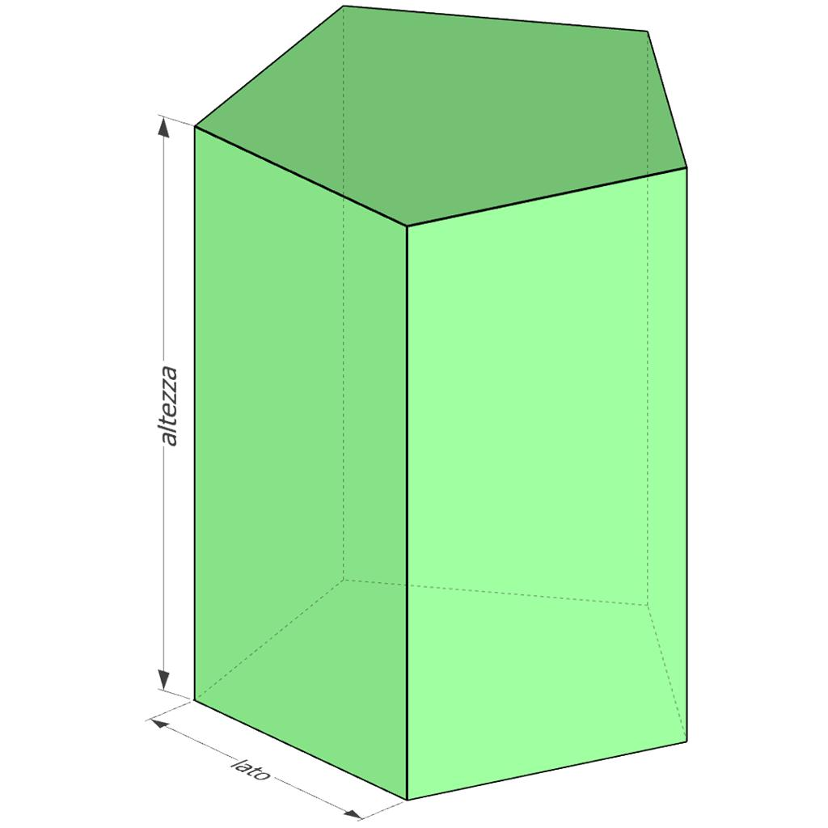
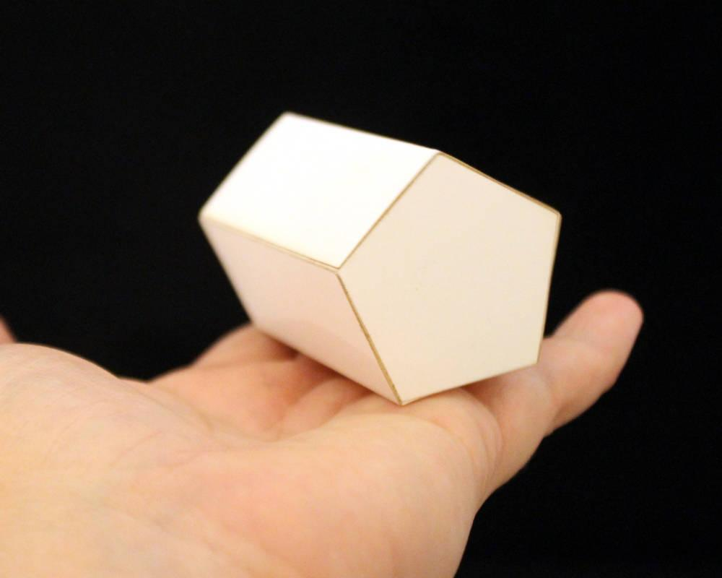
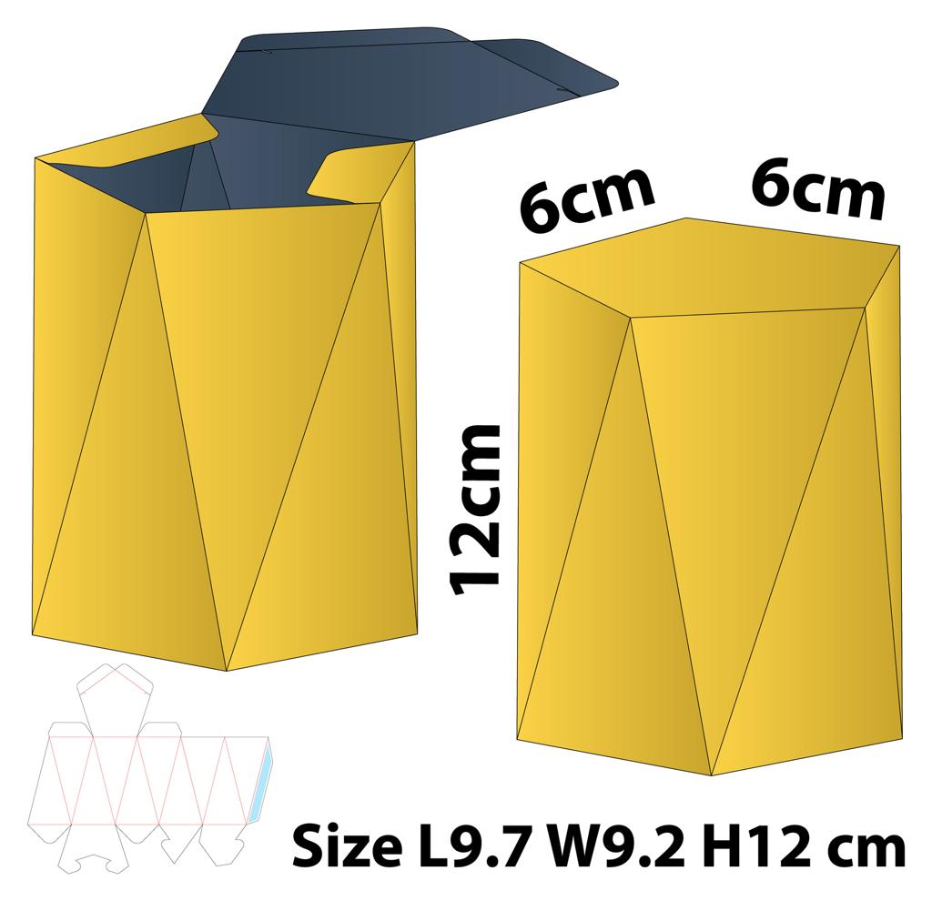
Pentagonal prisms can be used in:
- Architecture: Designing decorative columns and structures with pentagonal cross-sections.
- Packaging: Creating containers with five-sided cross-sections.
- Education: Demonstrating polyhedra, surface area, volume, and Euler's formula.
- Engineering and design: Modeling components with pentagonal cross-sections.
- Computer graphics: Representing three-dimensional polygonal objects.

Key Points
# Source: AI Source: Provided by: [Data Path: Persons Table -> ID Column: 1, Name_En Column: Motasem Essam] -> From: [ChatGPT] on [7/25/2026]
- A pentagonal prism has two congruent, parallel pentagonal bases.
- It has five lateral faces and seven faces in total.
- It has 15 edges and 10 vertices.
- Its volume is $V=Bh$.
- For a right prism, its lateral surface area is $A_{L}=ph$.
- Its total surface area is $A_{T}=A_{L}+2B$.
- It satisfies Euler's formula $V-E+F=2$.

Conclusion
# Source: AI Source: Provided by: [Data Path: Persons Table -> ID Column: 1, Name_En Column: Motasem Essam] -> From: [ChatGPT] on [7/25/2026]
A pentagonal prism is a polyhedron characterized by two congruent, parallel pentagonal bases connected by five lateral faces. It has seven faces, fifteen edges, and ten vertices, making it a useful example for understanding the structure of polygonal prisms.
Its main measurements can be determined using the volume formula $V=Bh$ and the total surface area formula $A_{T}=A_{L}+2B$. For a right prism, the lateral surface area is calculated using the base perimeter and perpendicular height. These properties connect the geometry of pentagons with the general formulas for prisms and polyhedra.
Understanding the pentagonal prism also makes it easier to study prisms with other polygonal bases, such as triangular, quadrilateral, and hexagonal prisms.

